**In an Emergency**

**TAKE ACTION**

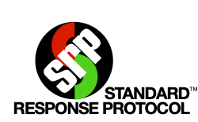

|  |  |  |  |  |
| --- | --- | --- | --- | --- |
| **HOLD** | **SECURE** | **LOCKDOWN** | **EVACUATE** | **SHELTER** |

**Standard Response Protocol – Public Address**

|  |  |
| --- | --- |
| **Medical  Emergency** | **Hold in your Room or Area. Clear the halls.** |
| **Threat Outside** | **Secure! Get inside. Lock outside doors.** |
| **Threat Inside** | **Lockdown! Locks, Lights, Out of Sight!** |
| **Bomb** | **Evacuate to (location) Shelter for Bomb!** |
| **Earthquake** | **Shelter for Earthquake!** |
| **Fire Inside** | **Evacuate to the (location)** |
| **Hazmat** | **Shelter for Hazmat! Seal your Rooms** |
| **Weapon** | **Lockdown! Locks, Lights, Out of Sight!** |
| **Tornado** | **Evacuate to (location) Shelter for Tornado!** |
|  |  |